

**ASSESSMENT 3 : ROBOTIC PROCESS AUTOMATION AND AI IN THE CLOUD**

**BUS5001 CLOUD PLATFORMS AND ANALYTICS**

**SUBMITTED BY:**

**STUDENT NAME: JAYALEKSHMI NAIR**

**STUDENT ID: 21894792**

# **Q4)Evaluating Cloud Based Technology**

## **Key Functionalities of NotebookLM**

In today’s academic environment, students and educators are increasingly using AI tools to improve learning and research. Google’s **NotebookLM** is one such AI-powered note-taking assistant designed to help with reading, summarizing, organizing, and understanding academic materials. As part of evaluating its use in a university setting, this section highlights how NotebookLM supports common academic tasks such as studying, writing, and managing course content. The following points explain its key features and how they can benefit students, researchers, and lecturers in their daily academic work.:

**1. Ask Questions Based on Your Notes**

You can upload your class notes, textbooks, or research papers into NotebookLM and ask questions. The AI only uses what you’ve uploaded to answer—so it stays focused and avoids wrong or off-topic answers.

Example in Uni: A student uploads lecture slides and asks, “What’s the difference between supervised and unsupervised learning?” The AI gives an answer based only on those lecture notes.

**2. Summarize Long Readings**

NotebookLM can quickly turn long documents (like research papers or chapters) into short summaries. This saves time and helps students understand big topics more easily.

Example in Uni: A student doing a literature review uploads several articles. The AI creates short summaries of each one, helping them find the key points faster.

**3. Make Study Guides and FAQs**

NotebookLM is helpful to study questions and answers from your uploaded notes. This feature is called the study guide. It’s helpful for testing yourself before exams come. The FAQ tool shows the most important or common questions found in your content and provides answers. These features are like flashcards and can help you remember important details

**4.Make Timelines and Organised Notes**

Another important feature is the ability to create timelines. For example, if your notes cover the history of data platforms, NotebookLM can turn that into a timeline. It also helps organise information clearly so that it’s easier to understand. This can help both students and teachers explain topics better.

**3. Organize and Link Notes**

You can create notebooks for different subjects and group related notes together. The AI also finds links between topics and helps you see how ideas connect.

Example in Uni: A student has notes on “data science” and “marketing.” The AI points out that both include “customer segmentation,” helping the student connect the two topics.

**4. Easy-to-Understand Explanations**

If there’s a word or topic you don’t understand, NotebookLM can explain it in simple language using your uploaded material.

Example in Uni: If a student doesn’t know what “regression analysis” means, the AI explains it using examples from their uploaded textbook.

**5. Gives Proper Citations**

When the AI gives an answer or summary, it shows where the information came from. This helps students use correct references in their assignments and avoid plagiarism.

Example in Uni: While writing a research essay, the AI provides information and also shows which document it came from, so the student can cite it correctly.

## **b.** **Demonstration of NotebookLM Features in an Academic Scenario**

For this task, I used **NotebookLM** to help with my revision and research for the subject **BUS5001 – Cloud Platforms and Analytics**. I uploaded several lecture PDFs and workshop files covering topics like **Data Storage**, Serverless computing, **data platforms**. I applied NotebookLM’s features in a real academic situation—specifically while preparing for my final assignment and reviewing important concepts from the course.

**1.Chatbot-Asking questions based on my study materials**

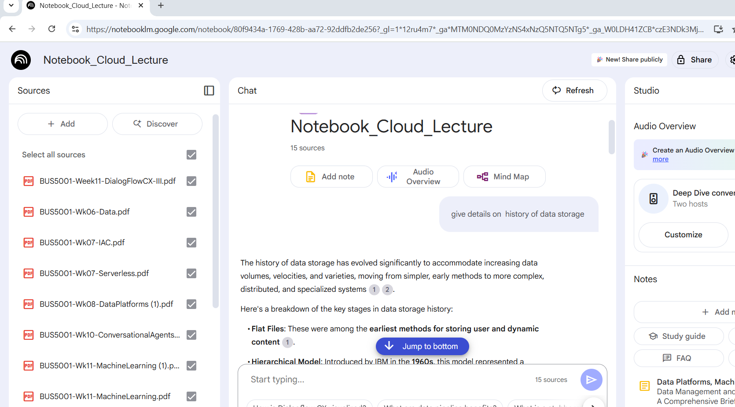

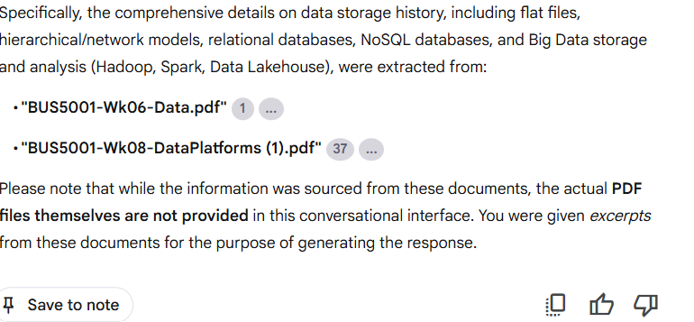

In my notebook, Notebook_Cloud_Lecture I created, I have asked specific question which is related to my course content. For example, I typed the question “give details on history of data storage”

”. The chatbot responded with a clear explanation drawn from my source materials, which included PDFs like "BUS5001-Wk06-Data.pdf" and"BUS5001-Wk08-DataPlatforms (1).pdf

The response was clear, well-structured, and traced the evolution from flat file storage and hierarchical models to relational databases, NoSQL systems, and modern big data architectures. It explained not only the technical developments—like the rise of JSON formats, column stores, and graph databases—but also contextualized the shift towards distributed computing with technologies like Hadoop and Apache Spark. I found it especially useful how the assistant connected concepts like the 3Vs of Big Data with real-world solutions such as HDFS and Delta Lake in data lakehouse architecture. The output included examples like Redis, Neo4j, and Delta Lake, and highlighted key terms such as ACID compliance, schema design, and in-memory processing. This made it easier for me to understand complex changes in data storage over time and relate them to my coursework in BUS5001 – Cloud Platforms and Analytics.

Why it was useful

The chatbot feature in NotebookLM was especially useful because it allowed me to interact with my own study materials in a simple, question-and-answer format. Instead of manually searching through multiple lecture slides or workshop PDFs, I could just ask specific questions—like “What is the history of data storage?”—and get clear, structured answers directly based on my uploaded content. This saved me a lot of time during revision and helped me better understand complex topics by breaking them down into easy-to-read sections. The chatbot also included references to the original documents, which made it easy to go back and review the source if needed.

**2. Study Guide – Automatically Generating Revision Questions**

Click on study guide feauture on Notebooklm and it gives us a Comprehensive Study Guide.

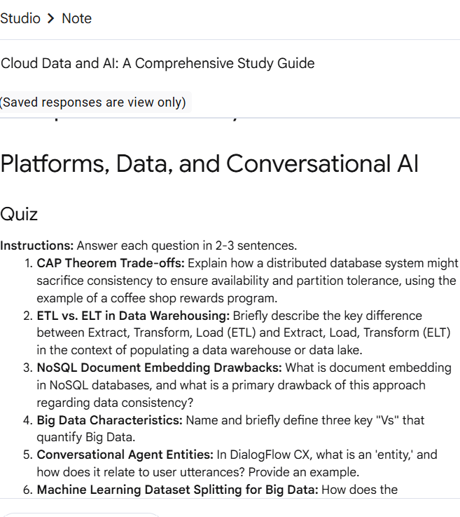The **chatbot and study guide features** in **NotebookLM** were used to create a comprehensive quiz titled **“Comprehensive Study Guide: Cloud Platforms, Data, and Conversational AI.”** This study guide was built using course materials from BUS5001 Cloud Platforms and Analytics, including lecture PDFs, workshop files, and glossary notes. By asking the chatbot targeted questions like “What are the drawbacks of document embedding in NoSQL?” or “Explain the difference between ROC and PR curves,” the tool generated accurate, course-aligned answers. These answers were then used to structure quiz questions and an answer key in 2–3 sentence formats to match exam-style expectations.

Why it was useful

The NotebookLM study guide feature was useful because it helped turn my lecture notes and workshop files into a structured set of quiz questions and answers, making exam preparation much easier and more focused. Instead of reading through long documents, I could ask the chatbot specific questions and get clear, concise answers based directly on the uploaded materials. This saved time, improved my understanding of key concepts, and allowed me to study in a more active and efficient way

**3) Timeline – Understanding the History Of Data Management and Analytics**

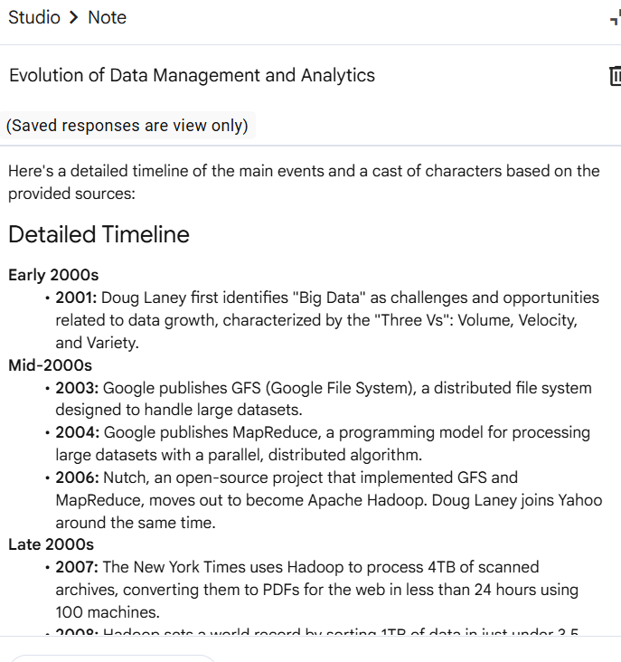NotebookLM’s **Timeline** feature automatically created a structured overview of the Evolution of Data Management and Analytics, turning large amounts of course content into a chronological format. The timeline began with Doug Laney's identification of “Big Data” in 2001 and moved through key milestones—like the release of Google File System (2003), MapReduce (2004), the creation of Apache Hadoop (2006), and major privacy regulations such as GDPR (2018) and Australia’s Consumer Data Right (2020). It also highlighted current topics covered in BUS5001, including machine learning workflows, conversational agent design, and serverless computing.

Why is was useful

This feature was especially useful for understanding **how different technologies, companies, and people have influenced the development of modern data management and analytics**. Instead of reading long lecture notes, I could see **the big picture at a glance**—what happened, when it happened, and who was involved. The timeline helped me **memorize dates and milestones** for exams, while the cast of characters gave life to abstract concepts by linking them to real people, organizations, and user roles (e.g., developers, customers, analysts). For example, it clarified how technologies like Hadoop and Databricks evolved from Google’s early research, and how current data ethics laws tie back to real-world companies like Acxiom.

**4. FAQ – To Recieve Quick Answers to Key Module Questions**

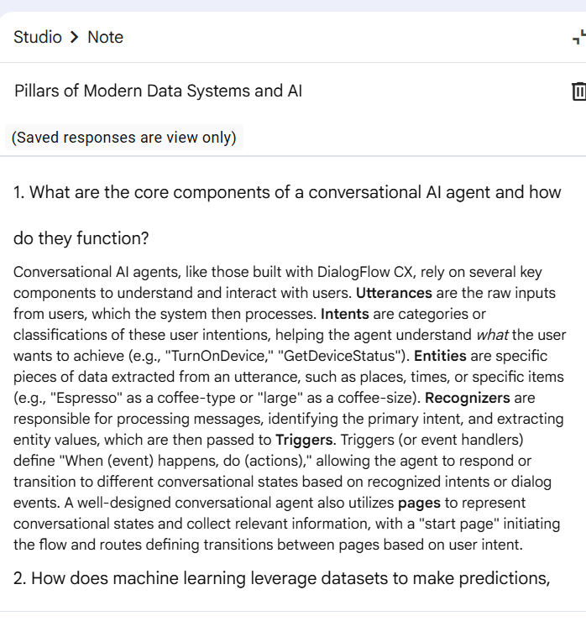The **FAQ (Frequently Asked Questions) feature in** NotebookLM automatically transformed complex academic content from BUS5001 – Cloud Platforms and Analytics into clear, concise question-and-answer format. By clicking the FAQ button, NotebookLM scanned through the uploaded lecture notes and generated detailed responses to key academic questions on topics such **as conversational AI, machine learning, big data, CAP theorem, infrastructure as code (IaC), data lakes, and data ethics.**

Each answer was structured in a logical, easy-to-read manner using key terms and examples that aligned with the course material—for example:

* It explained intents, entities, recognizers, triggers, and pages in DialogFlow CX.
* Clarified the machine learning model lifecycle from dataset creation to evaluation using metrics like MAE, RMSE, precision, recall, and AUC-ROC.
* It provided a real-world example for the CAP theorem, like the coffee shop reward system during a network partition.
* It distinguished between data privacy, protection, and security, using laws like GDPR and Australia’s Privacy Act to provide regulatory context.

Why is was useful

The FAQ feature in NotebookLM was useful because it transformed complex lecture content into clear, well-structured question-and-answer format, making it easier to understand and revise key topics. Instead of searching through pages of notes, I could instantly access concise explanations of concepts like conversational AI components, machine learning evaluation metrics, the CAP theorem, and data privacy principles. Each answer was grounded in the uploaded course material and written in a way that matched the expectations of short-answer exam questions. This saved a lot of time during study sessions and helped reinforce my understanding by presenting information in a focused, question-driven format. It felt like having a personalized digital tutor, offering reliable and exam-ready answers drawn directly from my own academic content.

**5. Briefing Doc – Summarising Key Themes Across All Documents**

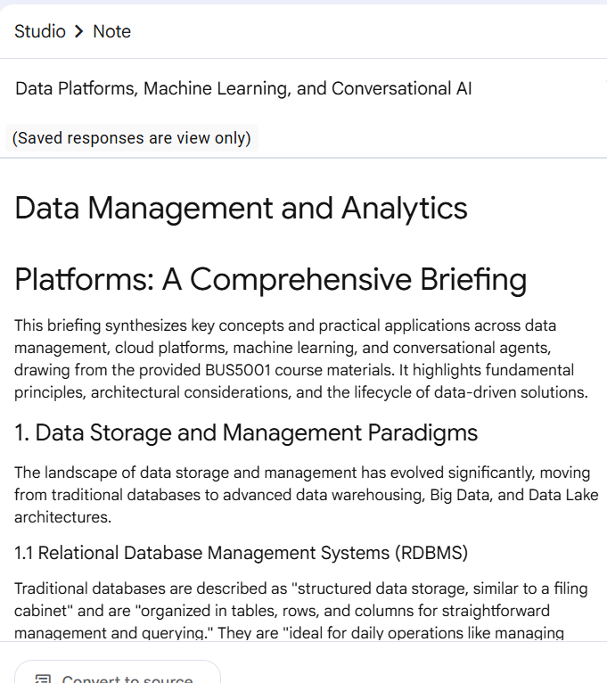 The **Briefing Doc button** in NotebookLM automatically pulled together all my uploaded BUS5001 lecture PDFs and workshop notes into a polished, multi-section report titled **“Data Management and Analytics Platforms: A Comprehensive Briefing.”** The tool grouped related ideas under clear headings—first outlining the evolution from traditional **RDBMS to Data Warehouses, NoSQL, Big Data, Data Lakes, and Delta Lake,** then walking through cloud-computing concepts such as **serverless architecture, micro-services, and Infrastructure as Code.** It even wove in practical examples (e.g., Azure Bicep deployments, Databricks clusters) and cited the exact BUS5001 PDFs next to each point for easy cross-checking.

Why It Was Useful

This Briefing Doc feature was a huge time-saver because it distilled an entire semester’s worth of readings into one coherent narrative, complete with inline citations and practical examples. Instead of piecing together notes from multiple sources, I instantly had a ready-made reference I could skim before exams, share with classmates, or adapt for presentations. The structured layout—moving from storage paradigms to cloud infrastructure, machine learning, conversational AI, and data ethics—made complex relationships between topics obvious at a glance. Essentially, it felt like having an automatically generated study guide and executive summary, letting me focus on understanding concepts rather than formatting documents.

## **c. Critical Analysis of NotebookLM Capabilities**

NotebookLM is an AI tool made by Google to help students with study and research. It can read lecture notes, create summaries, timelines, FAQs, and more. In this task, I tested NotebookLM using my BUS5001 subject materials to see how useful it is. This report looks at how accurate the tool is, how helpful it is for studying, and what problems it might have, like giving wrong or biased answers.

**1) Accuracy and relevance of the AI-generated output**

NotebookLM showed a high level of **accuracy and contextual relevance**, especially because it bases its responses **only on the documents uploaded** by the user. For example, when asked about the **history of data storage**, the chatbot provided a chronological explanation using references from uploaded PDFs like BUS5001-Wk06-Data.pdf and BUS5001-Wk08-DataPlatforms.pdf. The information was not only factually correct but also aligned closely with the course material, including technical terms (e.g., "Delta Lake", "ACID compliance") and accurate examples (e.g., Redis, Neo4j). This ensured responses were highly relevant to the academic context, making NotebookLM a reliable companion for revision and assignment support.

**2) Usefulness in Academic Workflows**

NotebookLM made study tasks easier by saving time and helping students focus better. The **Study Guide** turned notes into Q&A flashcards for exam revision**.** The **Timeline** showed important tech events in order, making it easier to understand history. The **FAQ tool** gave clear answers to hard topics like the CAP theorem and AI ethics. The **Briefing Doc** brought all the files together into a well-organized report with references. These tools helped students quickly review, understand key ideas, and prepare for exams. For example, in the BUS5001 class, it helped students study faster and stay more engaged.

**3) Limitations or concerns for instance bias or hallucination, provide evidence to support your conclusions**

While NotebookLM generally maintained high factual accuracy, there are some **known limitations and risks,** particularly around **AI hallucination**—where the model may generate convincing but incorrect or unverifiable information. This is especially risky if students blindly trust answers without checking the source citations. Though NotebookLM attempts to ground responses in the uploaded files, complex or ambiguous queries might still lead to oversimplified or incomplete outputs.

**Inaccurate Information (Hallucination):**

When asked about technical topics like CAP theorem or GDPR, sometimes the FAQ tool included outdated definitions or mixed up facts from different sources. For example, in the CAP theorem explanation, NotebookLM generalized some examples without explaining trade-offs clearly, which could confuse new learners.

**Overconfidence in Wrong Answers:**

The AI sometimes gave answers with a confident tone even when they were not fully correct, which can mislead students who don’t fact-check.

**Bias in Examples or Focus:**

The AI often used U.S. or European laws (like GDPR or HIPAA) in responses, giving less attention to Australian laws like the Privacy Act 1988—even when those were more relevant to the course (BUS5001).

**Lack of Deep Context Understanding:**

In some FAQ responses, it summarized complex ethical theories in overly simplified ways, missing important nuances, which might not be helpful for academic writing.

**Dependence on Source Quality**:

If the uploaded materials were unclear or poorly structured, the AI sometimes misunderstood them or gave vague answers, showing how much it depends on the quality of the input data.

**Conclusion**

NotebookLM proved to be a useful tool for supporting academic tasks by automating note-taking, summarization, question generation, and content organization. Its features like the Study Guide, Timeline, FAQ, and Briefing Doc aligned well with student needs in the BUS5001 course, helping with revision, concept understanding, and exam preparation. However, the tool also showed limitations such as occasional hallucinations, overgeneralizations, and reliance on input quality. Therefore, while NotebookLM can enhance learning efficiency, its outputs should be reviewed critically and supported with human judgment for academic accuracy and integrity.

**Summary**

NotebookLM helped simplify academic tasks by turning study materials into clear summaries, timelines, FAQs, and structured reports. It saved time, improved understanding, and supported exam preparation in a practical way. While very helpful, the tool sometimes made mistakes or gave unclear information, so students should always double-check the output. Overall, NotebookLM is a valuable assistant for learning, but it works best when used alongside human review and critical thinking.

…………………………………………………………………………………………………………………………………………………………..